The following is a more technical description of tweets table:

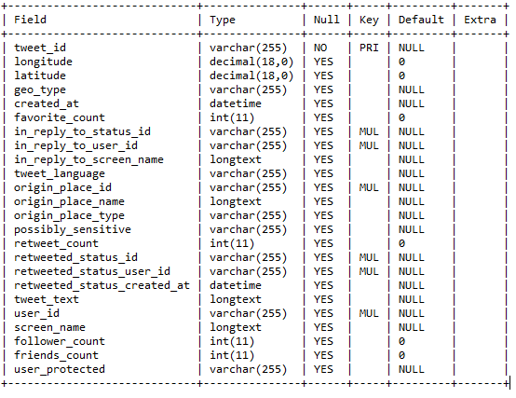

For each user, we also have their

* Friends count (the **number** of people they are following)
* Followers count (the **number** of people following them)
* The time when this user account was created
* A URL that might point to the users personal website (Optional)
* **Number** of public lists the user is a member of
* Whether the user is verified or not (Optional. Relevant only to high profile users)

The following is a screenshot of the design of users table from access.

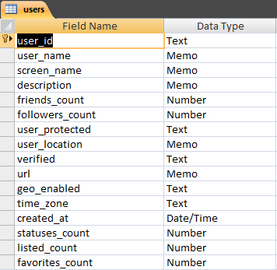

The following are screenshots of hashtags, urlstable and usermentions:

Hashtags:

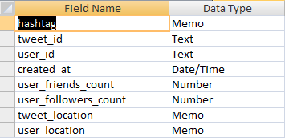

urlstable:

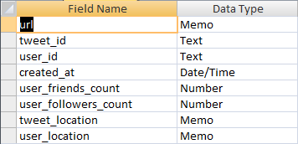

usermentions:

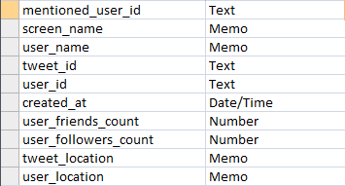

Note: I have selected the storage format as .mdb files that can be manipulated with Microsoft Access. I chose this because I can easily use them with python’s pyodbc interface. For anyone who will be taking over in future, I suggest they use MySQL database as Access is not scalable and will peak at 2 GB. I am able to use access because we are only looking at june and july tweets at the moment.